ZTT Compliance Rules on Risk Assessment

- General Provisions
- Pursuant to the relevant laws, rules, and regulations of China and other countries in which the Jiangsu Zhongtian Technology Co., Ltd. (“Company” or “ZTT”) operates (collectively “Applicable Laws”) and the Compliance Guidelines, the Employees’ Compliance Code of Conduct and other compliance policies and requirements of the Company (“ZTT Compliance Rules”), and according to the implementation plan and staff requirements under the compliance management system, and taking into account the business environments in which the Company operates, the Company hereby formulate this Rules to regulate the Assessment of compliance risk related to the business activities of the Company.
- These Rules apply to the business activities of the Company and the foreign and domestic controlled subsidiaries (hereinafter as the “Subsidiaries”). ZTT Compliance Standard Department will supervise the implementation of this Rules by the above Subsidiaries of the Company.
- This Rules apply to all Employees of the Company and its Subsidiaries.
- Definitions
1. “Compliance” means the adherence to the applicable laws, international conventions, Compliance Codes of International Organization, regulatory provisions, industrial standard, business practice, ethics and the Company’s articles of association and rules and regulations and other relevant requirements by the Company and its Subsidiaries in their regular course of business.
2. “Compliance Risks” refers to the possible negative impacts caused by legal sanctions, administrative penalties, significant loss of property or reputation occurs to the Company and its Subsidiaries or Employees as a result of their Non-compliance Conducts.
3. “Appropriate Compliance Department”, depending on the entities responsible for the business operations, refers to Compliance Standard Department of the Company; or Compliance Department or Compliance Officers of the Subsidiaries.
4. “Third Parties” refers to all entities such as agents, advisers and other intermediaries, consultants, representatives, distributors, contractors, subcontractors and suppliers, consortia, joint venture partners and other kind of third parties with whom it has business relationships or with whom it works to obtain orders or permits (whether an individual, partnership, corporation or unincorporated entity) engaged by the Company or any Subsidiaries in any forms or under any titles.

5. “Compliance Risk Assessment” refers to the regular or interim Assessment on compliance risks of the Company and its Subsidiaries conducted by appropriate compliance department, as well as its subsequent drawn up of Assessment report and solutions..
6. “Assessment Unit” refers to the Appropriate Compliance Department or other one or more departments which shall, pursuant to this Rules, be in charge of compliance risk Assessment, generally including other departments of the Company acting in conjunction with the Appropriate Compliance Department.

- Duties of the Department in Charge of Compliance Risk Assessment
- The Appropriate Compliance Department shall, under the supervision of the Compliance Standard Department of the Company, be responsible for carrying out risk Assessment in accordance with this Rules.
- The Appropriate Compliance Department shall conduct risk Assessment once every 24 months in accordance with this Rules. Besides such regular risk Assessment, upon the request of the Compliance Committee, the Compliance Standard Department of the Company may conduct risk Assessment in respect of the following events or situations:
1. Any change occurs to the businesses of the Company or any of the Subsidiaries, which the Compliance Standard Department of the Company believes will affect the risk ranking in respect of the Company, including but not limited to the following situations:
- Mergers and acquisitions involving the Company or any of the Subsidiaries;
- Participation by any of the Subsidiaries in foreign contracting business;
- Entrance by the Company or any of the Subsidiaries into new industries or new markets;
- Any political change that has taken place in the region where the Company or any of the Subsidiaries operates a project;
2. Any reports, from employees or anyone informant, reflecting compliance risks in a given area are not properly addressed.
3. Compliance requirements of the Subsidiaries or industrial standards are materially changed;
4. Any other event or situation which may materially affect the result of the Compliance Risk Assessment over any of the Subsidiaries.

- Compliance Risk Assessment Procedure
- Compliance risk Assessment procedure consists of the following three parts (as described in Annex 1 Compliance Risk Assessment Flow Chart: 1. collecting the information about the unit subject to Assessment as required in the Compliance Risk Assessment Form (see Annex 2 Compliance Risk Assessment Form; 2. interviewing the managing staffs selected by the Appropriate Compliance Department of the unit which is subject to such risk Assessment and the department which is responsible for risk Assessment against the said unit and discussing with them about the issues listed in the Risk Assessment Questionnaire (see Annex 3 Risk Assessment Questionnaire; 3. analyzing the risk-related information, drafting a compliance risk Assessment report and providing primary suggestions.
- The unit subject to risk Assessment shall cooperate with the Appropriate Compliance Department in its obtaining sufficient information to complete the Risk Assessment Form. When necessary, the Compliance Standard Department of the Company shall complete these duties by cooperating with other departments, including Asset Finance Department(s), Human Resources Department(s), Market Development Department(s), and the Appropriate Compliance Department of the unit subject to such risk Assessment. The unit subject to such risk Assessment shall fill the company information in the said form within 60 days after the starting of the risk Assessment, and shall keep the Appropriate Compliance Department informed of the progress of the work.
- After the starting of the risk Assessment procedure, the unit subject to such risk Assessment shall submit a list of management staff to the Assessment Unit and select, in coordination with the Assessment Unit, the management staff who will be interviewed face by face or by phone call by the Assessment Unit. The Assessment Unit shall select 3-4 business managers from the unit subject to such risk Assessment and interview them, and such selected business managers shall answer the questions concerning compliance risks. The Assessment Unit shall select such interviewee according to following criteria:
1. The interviewees shall be in charge of the regional, national or large-scale project;
2. The interviewees shall be selected from various regions as much as possible;
3. There shall be at least three interviewees from the key business areas and other related business areas of the such unit subject to risk Assessment; and
4. Other criteria the Appropriate Compliance Department of the Assessment Unit think appropriate.
The list of interviewees shall be confirmed by the Assessment Unit. The selected interviewees shall faithfully answer the questions in the Compliance Risk Assessment Questionnaire. The interviewees shall be interviewed face by face or by phone call by the Assessment Unit. The Assessment Unit shall record the contents of the interview. If the interviewees are unable to participate in a face-to-face interview or telephone interview, the Compliance Risk Assessment Questionnaire can be sent to them and filled in by them. The Assessment Unit has the discretion to decide whether to conduct additional interview based on the information filled in the said questionnaire.
- After collecting relevant risk information, the Assessment Unit shall review the contents of company information and questionnaires, and assess the compliance risks faced by the Company based on the relevant contents, especially pay special attention to the changes of the risks after each Assessment. The Assessment Unit shall issue a compliance risk Assessment report which shall disclose the compliance risks or problems identified or discovered by it and propose a preliminary solution to the risks, within 60 days of the conclusion of the compliance risk Assessment,
- If the unit subject to such risk Assessment is the Company, the Assessment Unit shall submit the compliance risk Assessment report to the chief compliance officer of the Company for approval; if the unit subject to such risk Assessment is any of the Subsidiaries, the Assessment Unit shall submit the compliance risk Assessment report to its Appropriate Compliance Department for approval and to the Compliance Standard Department of the Company for recordation,
- After receiving the decision whether the risk Assessment report is approved, the Assessment Unit shall notify immediately the unit subject to such risk Assessment of the risk mitigation solution to be applied, and the unit subject to such risk Assessment shall, in cooperation with the Appropriate Compliance Department and internal and external experts of all other related units, ensure the effective implementation of the risk mitigation solutions.
- If the Assessment Unit discovers certain risk in the biding process, third party employment or procurement in the course of the compliance risk Assessment, the Assessment Unit shall notify the relevant departments of the unit involved, and thereafter, shall deal with such risk according to the examination and approval procedure for such kind of compliance risks.
- The Compliance Standard Department of the Company shall maintain all important documents for each risk Assessment (including a complete Risk Assessment Questionnaire, a Risk Assessment Form and a compliance risk Assessment report and other necessary documents). All such documents shall be kept for at least 24 months.

- Miscellaneous

- If the Company or any of the Subsidiaries breach this Rules and fail to complete the compliance risk Assessment or violates any laws, regulation or bylaws in the course of the compliance risk Assessment, it shall be criticized in a circulated notice, and the persons involved shall be held to be liable for such a breach or violation and be punished according to the seriousness of the breach or violation.
- Any question involving this Rules may be submitted to the Appropriate Compliance Department.
- The Compliance Standard Department of the Company shall on behalf of the Company, exercises the supervision on the implementation of this Rules in its departments, and it has the ultimate right to instruct and interpret the implementation of this Rules.

Annex: 1. Compliance Risk Assessment Flow Chart
2. Compliance Risk Assessment Form
3. Risk Assessment Questionnaire

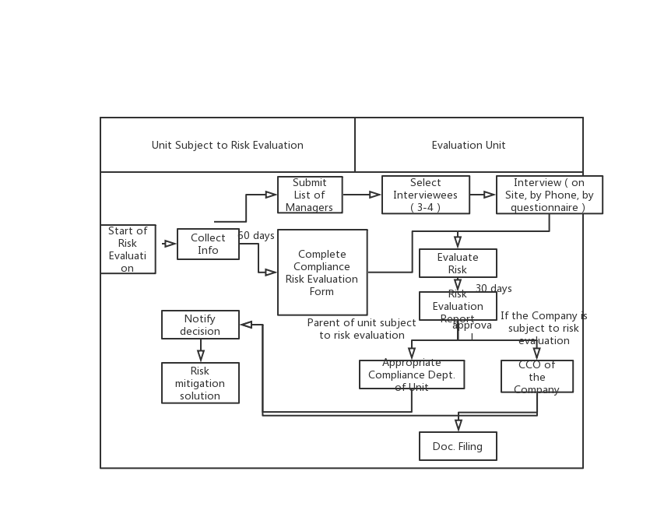
Annex 1 Compliance Risk Assessment Flow Chart

Annex 2
Compliance Risk Assessment Form

Corporate information
1. Company address and Company business (available from the relevant management department)
(1) List the countries in which the Company has offices.
(2) What are the country offices where staff or managers have actual operations?
(3) How many formal employees are there in each office?
(4) The name, resume and direct leader in charge of each office.
2. Joint Ventures and Affiliated Entities (available from the relevant management department)
(5) Does the Company have joint venture partners?
- If yes, please provide the name and shares of the joint venture company, the number of positions in the joint venture management position and the name and position of the specific personnel, the names of other legal or beneficial owners or business operators (including their nationality and company address), the date that the Company establishes the joint venture and the business scope of the joint venture.
(6) List the names of the Subsidiaries which are active in business operations, the Company's shares in them, and the names of other legal or beneficial owners and their shares and rights, their nationality and company address.
Collect the organizational chart of the Company that specifies the ownership structure.
- Have the directors or senior management of the Subsidiaries recently held a government position or a public office? (Confirmed with the Human Resources Department or other internal business units if necessary).
3. Customers and operation income (available from the relevant management department)
(7) Based on the contract amount in the past two years, which countries are the five largest customers of the Company?
(8) According to the Assessment of the contract amount in the past two years, what are the five countries with the highest Contract value of the company?
(9) According to the contract amount Assessment, what are the five countries with the highest cumulative contract amount so far?

4. Financial control (available from the Asset Finance Department(s))
(10) How many bank accounts does the Company have? (Which shall be counted according to the number of projects/number of accounts)
(11) In the past two years, which branches or subsidiaries have requested most frequently withdrawals of cash?
(12) In the past two years, which five countries (offices, project departments) use the most cash?
(13) In the past two years, has the Company paid cash to an agent or sales consultant?
(14) In the past two years, has the Company incurred the travel expenses of any foreign government officials?
- If happened, please list the name and position of the government official, the travel destination, the date of travel and the purpose of the trip, and the total cost of the Company.
5. Gifts and Hospitality (available from the Asset Finance Department(s))
(15) In which countries the salespersons of the Company or any of the Subsidiaries have received more than 3 requests for gifts or hospitality in the past two years?
(16) How many gifts have been approved in the past two years? And list the gifts, recipients, addresses and gift-giving purposes.
(17) Provide information about the payment of money which the Company has spent on charitable donations in the past two years and the names of the charity organizations to which such donations have been made.
6. Third Party (available from the Procurement and Supply Department)
(18) How many agents or consultants are currently used by the Company?
(19) How many new agents or consultants has the Company employed in the past two years?
- How many agents or consultants have been assessed by third party to be of above Risk Class One after due diligence investigation? Provide detailed information.
(20) How many agents or consultants have been recommended or rejected in the past two years?
(21) List the names of the five largest agents or consultants by amount paid to them by the Company or any of the Subsidiaries in the past two years, and explain separately the amount paid to each entity?
7. Investigations and Audits
(22) How many allegations/reports of misconduct have the Company received through the reporting system in the past two years? How many allegations/reports of misconduct received through other channels?
- Of which, as to how many reports, internal investigation has been conducted? And as to how many reports, external investigation has been conducted?
(23) Has the Company conducted an investigation as to corruption or collusion or other misconduct in the past two years?
- If such investigation has happened, please provide a brief description of the allegations for each investigation (e.g. “bribery to officials of the Ministry of the Interior”; conspired bidding or collusive pricing with a company), the starting date of the charge and the final decision (or, if the investigation is ongoing, provide a brief description of the status of the investigation).

Annex 3

Compliance Risk Assessment Questionnaire
1. Please list the main government agencies with which you cooperate in connection with your business activities in the region/country where you are or any of your project is based (including but not limited to central or local governmental agencies, state-owned companies, state-owned development company and other enterprises owned or controlled by a government).
Are you aware of allegations of fraud, corruption or conspiracy against the above-mentioned government agencies? If yes, please describe these allegations in detail.
2. What do you think are the three major difficulties which will be faced by the Company when maintaining anti-corruption compliance in your region/country or over your project?
Please provide information as detailed as possible, for example, extortion from all parties (army, police, tax, customs, Ministry of Mines, Ministry of Environment, trade unions, labor offices, local residents), normal office acceleration fees or facilitation payments (to customs, taxation, immigration, engineering, contract, Labor, Social Security, Ministry of Finance, various clerks, secretaries, etc.), and lack of access to actual information, etc.)
3. Please provide actual information about giving gifts and hospitality for your business in your region/country or for your project.
(1) The frequency of gifts and hospitality in your region/country or project.
(2) The purpose of giving such gifts and hospitality;
(3) The person(s) to whom you have given gifts and hospitality;
(4) The most expensive gift you have provided in the past year?
(5) The frequency you have had dinner with government officials and the amount of payment made by you?
(6) How often are other types of hospitality or recreational activities?
(7) What hospitality and recreational activities have you provided to foreign government officials in the last year?
4. In last year, how many times has the Company been required to pay for customers (including government officials) for domestic or international departing travel from the place of your business or your region/country?
5. Please describe the cash payments for conducting business activities in your region/country or project (including business activities with suppliers, lawyers or other service agencies).
6. How many petty cash payments have been made to local government officials, police and soldiers in your region/country or for your project in the last year?
7. What measures do you think the Company can take to enhance the compliance culture of business partners, the Subsidiaries or joint ventures in your region/country or related to your project?
8. What do you think is the most serious compliance risk faced by the Company at the moment?
9. Do you want to provide any more information, if yes, please provide such information in the blank below?

Investigator:
Interviewee:
Date:

"foreign government official" means the official leader or employee of a federal, state, provincial, county or municipal government or any department or institution; the leader or employee of a wholly owned or joint venture or company of the government ("state-owned enterprise"); any officer or employee of an international public organization (e.g., the World Bank, the United Nations or the European Union); any foreign political party or its official; or any political candidate. Foreign government officials include officials at all levels of government, regardless of rank, title or position.

